---. . .qQ1
START

DECLARE num1, num2, sum AS INTEGER

DISPLAY "Enter first number: "
READ num1

DISPLAY "Enter second number: "
READ num2

sum ← num1 + num2

DISPLAY "Sum = ", sum

END

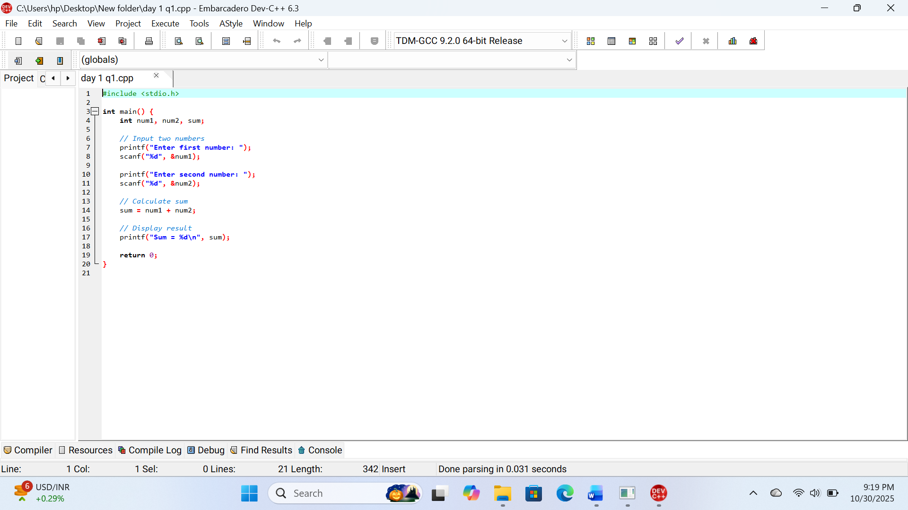
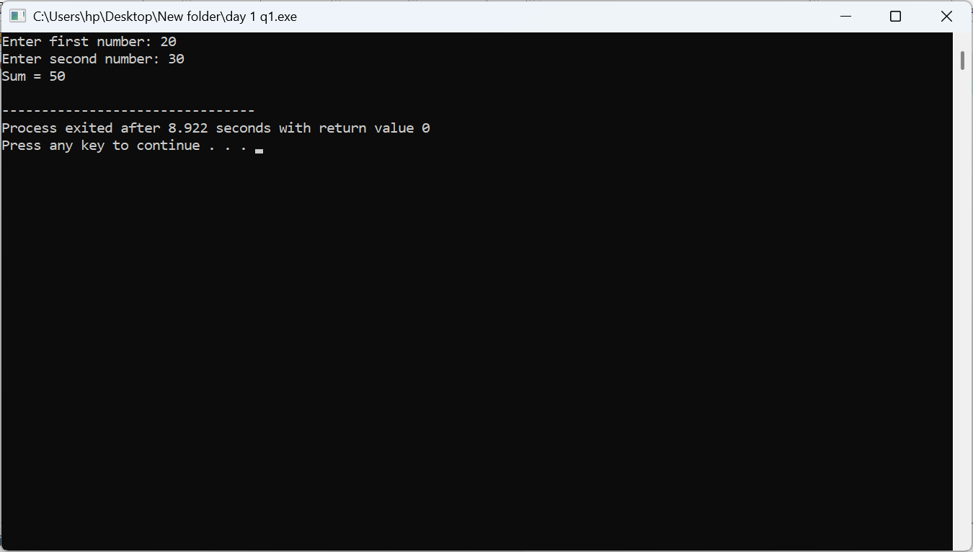

Step 1: Start
Step 2: Declare three integer variables: num1, num2, and sum
Step 3: Display message "Enter first number:"
Step 4: Read the first number and store it in num1
Step 5: Display message "Enter second number:"
Step 6: Read the second number and store it in num2
Step 7: Calculate the sum → sum = num1 + num2
Step 8: Display the result → "Sum = ", followed by the value of sum
Step 9: Stop

flowchart

│ Start Program │
└───────┬─────────────┘
│
▼
┌───────────────────────┐
│ Declare num1, num2, │
│ and sum as integers │
└─────────┬─────────────┘
│
▼
┌───────────────────────┐
│ Print "Enter first │
│ number:" │
└─────────┬─────────────┘
│
▼
┌───────────────────────┐
│ Read num1 (scanf) │
└─────────┬─────────────┘
│
▼
┌───────────────────────┐
│ Print "Enter second │
│ number:" │
└─────────┬─────────────┘
│
▼
┌───────────────────────┐
│ Read num2 (scanf) │
└─────────┬─────────────┘
│
▼
┌───────────────────────┐
│ sum = num1 + num2 │
└─────────┬─────────────┘
│
▼
┌───────────────────────┐
│ Print "Sum = " and │
│ display sum │
└─────────┬─────────────┘
│
▼
┌─────────────────────┐
│ End Program │
└─────────────────────┘

Q2
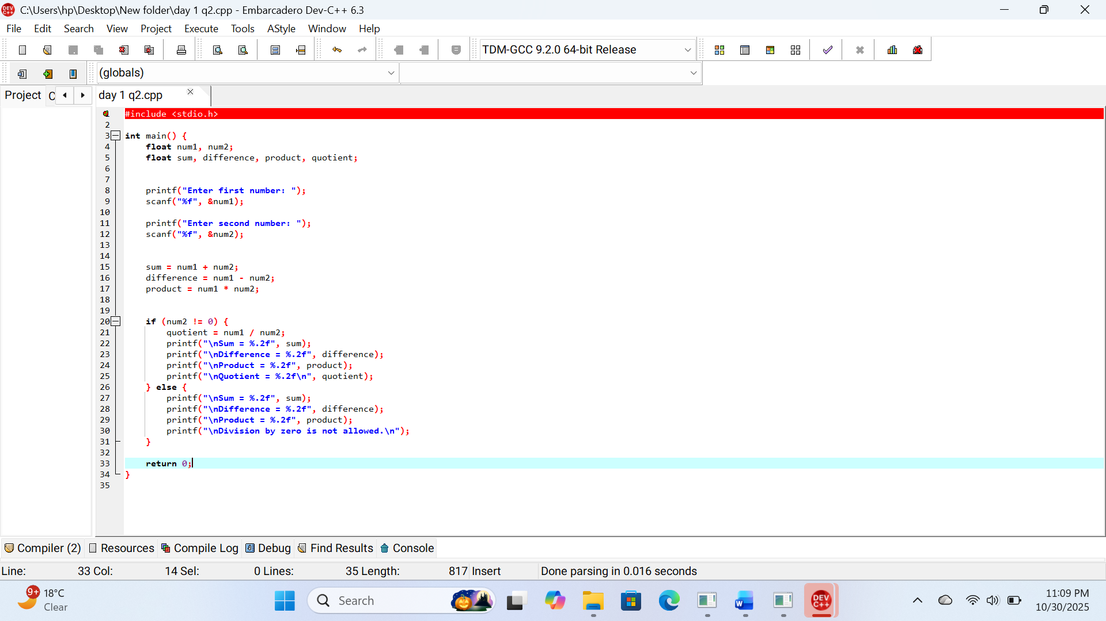

Algorithim
Step 1: Start
Step 2: Declare variables num1, num2, sum, difference, product, quotient as float.
Step 3: Prompt the user to enter the first number and store it in num1.
Step 4: Prompt the user to enter the second number and store it in num2.
Step 5: Compute
sum = num1 + num2
difference = num1 - num2
product = num1 * num2
Step 6: Check if num2 != 0:
If true:
- Compute quotient = num1 / num2
- Display sum, difference, product, and quotient
Else:
- Display sum, difference, product
- Display “Division by zero is not allowed.”
Step 7: Stop
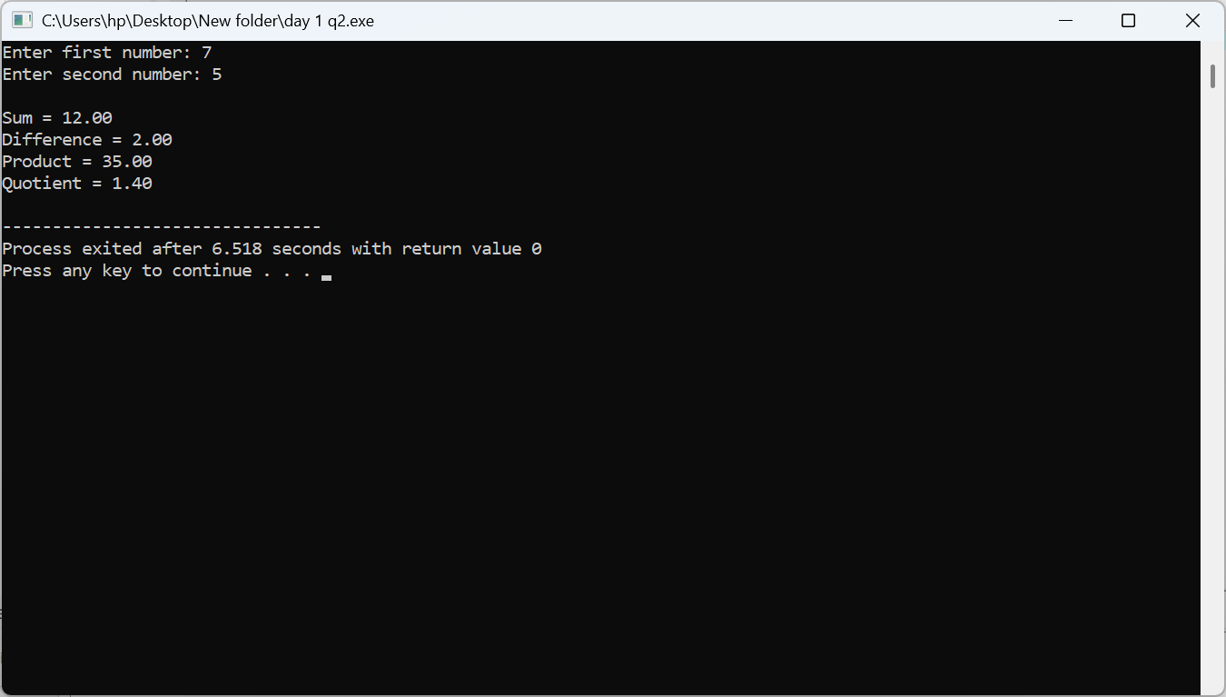
Flowchart
┌──────────────────────────┐
│ Start │
└───────────┬──────────────┘
│
┌───────────▼──────────────┐
│ Declare variables │
│ num1, num2, sum, diff, │
│ product, quotient (float) │
└───────────┬──────────────┘
│
┌───────────▼──────────────┐
│ Input num1 │
└───────────┬──────────────┘
│
┌───────────▼──────────────┐
│ Input num2 │
└───────────┬──────────────┘
│
┌───────────▼──────────────┐
│ sum = num1 + num2 │
│ diff = num1 - num2 │
│ product = num1 * num2 │
└───────────┬──────────────┘
│
┌───────────▼──────────────┐
│ Is num2 ≠ 0 ? │
└───────┬─────┬────────────┘
│Yes │No
┌───────▼─┐ └────────────┐
│ quotient=│ │
│ num1/num2│ │
│ Display │ │
│ sum, diff│ │
│ product, │ │
│ quotient │ │
└───────┬──┘ │
│ │
▼ ▼
┌───────────────────────────┐
│ Display “Division by zero │
│ not allowed.” │
│ (and sum, diff, product) │
└───────────┬───────────────┘
│
┌───────────▼──────────────┐
│ Stop │
└──────────────────────────┘
Q3

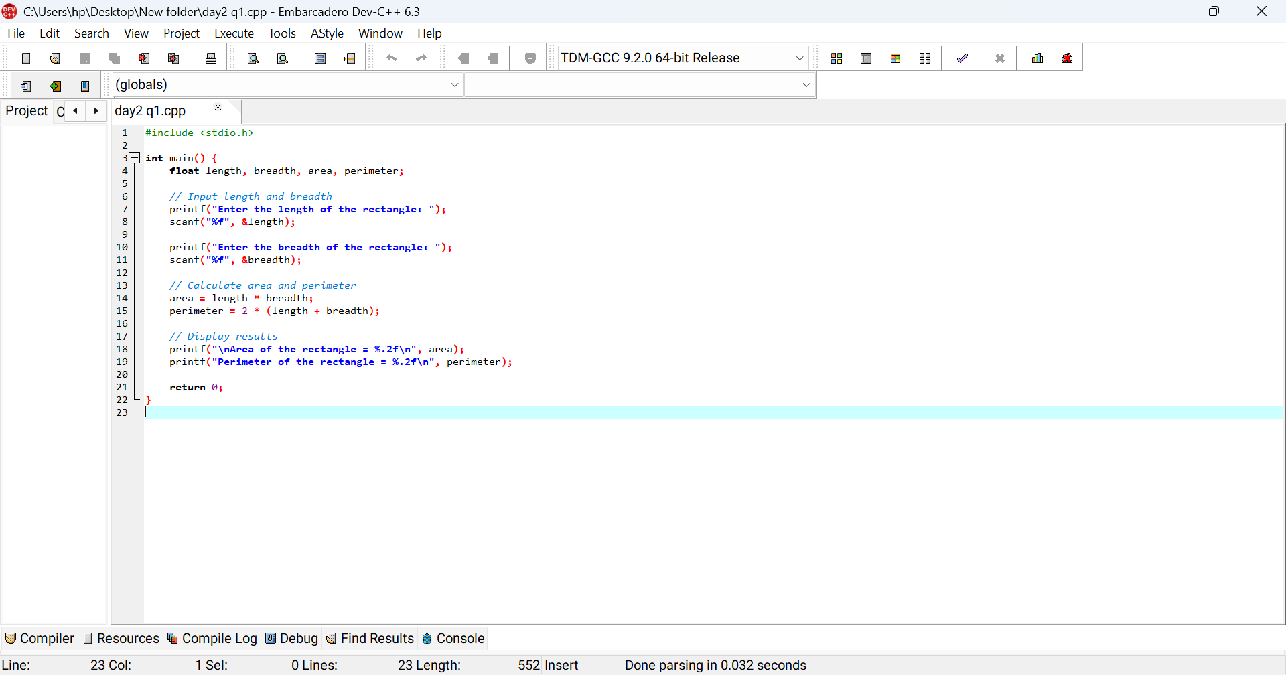Step 1: Start
Step 2: Declare variables length, breadth, area, and perimeter as float.
Step 3: Prompt the user to enter the length of the rectangle and store it in length.
Step 4: Prompt the user to enter the breadth of the rectangle and store it in breadth.
Step 5: Calculate the area using the formula:
area = length * breadth
Step 6: Calculate the perimeter using the formula:
perimeter = 2 * (length + breadth)
Step 7: Display the area and perimeter.
Step 8: Stop
flowchart
┌───────────────────────────┐
│ Start │
└────────────┬──────────────┘
│
┌────────────▼──────────────┐
│ Declare variables: │
│ length, breadth, area, │
│ perimeter (float) │
└────────────┬──────────────┘
│
┌────────────▼──────────────┐
│ Input length │
└────────────┬──────────────┘
│
┌────────────▼──────────────┐
│ Input breadth │
└────────────┬──────────────┘
│
┌────────────▼──────────────┐
│ area = length * breadth │
└────────────┬──────────────┘
│
┌────────────▼──────────────┐
│ perimeter = 2*(length + │
│ breadth) │
└────────────┬──────────────┘
│
┌────────────▼──────────────┐
│ Display area and │
│ perimeter │
└────────────┬──────────────┘
│
┌────────────▼──────────────┐
│ Stop │
└───────────────────────────┘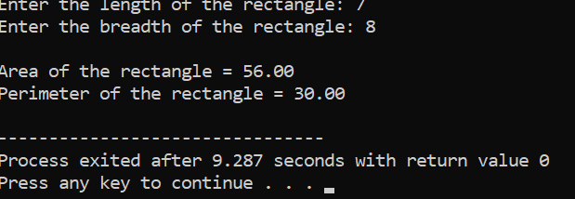
Q3 end
Q4
START

DECLARE radius, area, circumference AS float
SET PI = 3.14159

PRINT "Enter the radius of the circle: "
READ radius

CALCULATE area = PI * radius * radius
CALCULATE circumference = 2 * PI * radius

PRINT "Area of the circle = ", area (formatted to 2 decimal places)
PRINT "Circumference of the circle = ", circumference (formatted to 2 decimal places)

END
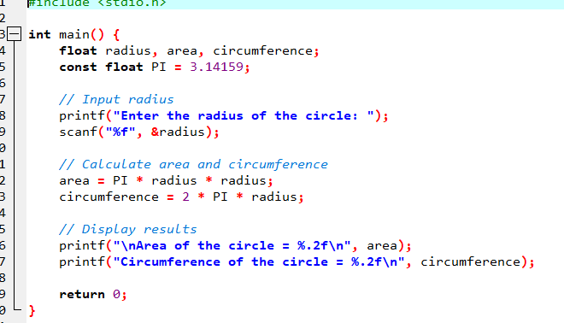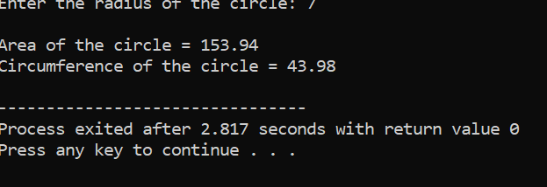
Algorithim
Step 1: Start
Step 2: Declare variables radius, area, circumference, and constant PI = 3.14159.
Step 3: Prompt the user to enter the radius of the circle.
Step 4: Read the radius value from user input.
Step 5: Calculate the area using the formula
area = PI * radius * radius
Step 6: Calculate the circumference using the formula
circumference = 2 * PI * radius
Step 7: Display the area and circumference.
Step 8: Stop
┌────────────────────┐
│ Start │
└───────┬────────────┘
│
▼
┌──────────────────────────┐
│ Declare variables: │
│ radius, area, │
│ circumference, PI=3.14159│
└──────────┬───────────────┘
│
▼
┌─────────────────────────────┐
│ Input radius from user │
└──────────┬──────────────────┘
│
▼
┌─────────────────────────────┐
│ area = PI * radius * radius │
└──────────┬──────────────────┘
│
▼
┌─────────────────────────────┐
│ circumference = 2 * PI * │
│ radius │
└──────────┬──────────────────┘
│
▼
┌─────────────────────────────┐
│ Display area and │
│ circumference │
└──────────┬──────────────────┘
│
▼
┌───────────────┐
│ Stop │
└───────────────┘
Q5

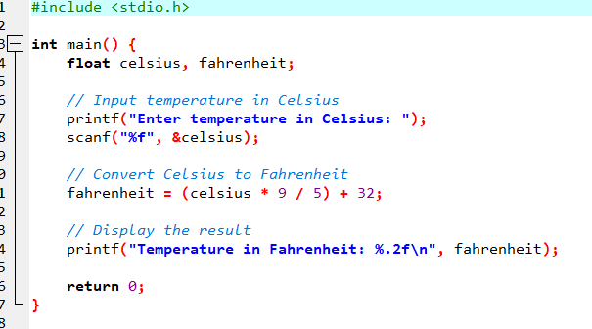
Step 1: Start
Step 2: Declare two float variables — celsius and fahrenheit
Step 3: Prompt the user to enter the temperature in Celsius
Step 4: Read the input value and store it in the variable celsius
Step 5: Calculate Fahrenheit using the formula:
fahrenheit = (celsius * 9 / 5) + 32
Step 6: Display the result (Fahrenheit value) on the screen
Step 7: Stop
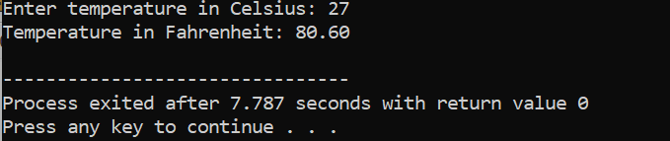
┌────────────────────────────┐
│ Start │
└────────────┬───────────────┘
│
▼
┌────────────────────────────┐
│ Declare celsius, fahrenheit│
└────────────┬───────────────┘
│
▼
┌────────────────────────────┐
│ Input temperature in │
│ Celsius (celsius) │
└────────────┬───────────────┘
│
▼
┌────────────────────────────┐
│ Calculate fahrenheit = │
│ (celsius * 9 / 5) + 32 │
└────────────┬───────────────┘
│
▼
┌────────────────────────────┐
│ Display fahrenheit │
└────────────┬───────────────┘
│
▼
┌────────────────────────────┐
│ Stop │
└────────────────────────────┘

Q6
